Welcome to
Trinity Lutheran Church
Lutheran Church—Missouri Synod
A Stephen Ministry Congregation

1354 South Otsego Avenue
Gaylord, Michigan 49735
Church Phone: (989) 732-4816

Church Email: secretary@trinitygaylord.com
www.trinitygaylord.com

Office Hours: Monday through Friday 9am – 1pm

OUR PURPOSE
…is to LOVE GOD, LOVE OTHERS, AND SERVE THE WORLD by worshiping the Lord Jesus, bringing our members into Christ-like maturity, and equipping them through Word and Sacrament for their mission and ministry. We go heart to heart into the world with Jesus, sharing His love, caring for one another, praying, and bringing the lost into a relationship with Christ, by the working of the Holy Spirit.

June 5, 2022
Pentecost Sunday
Preacher: Rev. Paul Schneider

ABOUT OUR WORSHIP
We welcome all who gather here today! We are blessed to celebrate together the mercy, grace, and love we have from God through the death and resurrection of our Lord Jesus Christ.

Children: Families with children are very welcome here. Having children in church is important so they can begin to learn about their faith in Jesus, and it’s good for the whole congregation to see. Please feel comfortable keeping “squirmy” kids in the service. This is where they belong, too!

Pew Cards: Guests and Members, please fill out the Guest/Member card located on the back of the pew in front of you and pass it to the end of the aisle. If you forget you can put it in the offering plate on your way out.

If standing is difficult: Please feel free to remain seated during any portion of the service. Please let an Elder or Usher know if you need communion in your pew seat.

About our celebration of Holy Communion: We celebrate the Lord’s Supper in the confession and glad confidence that, as he says, our Lord gives into our mouths not only bread and wine but his very body and blood to eat and to drink for the forgiveness of sins and to strengthen our union with him and with one another. Our Lord invites to his table those who trust his words, repent of all sin, and set aside any refusal to forgive and love as he forgives and loves us, that they may show forth his death until he comes.

Because those who eat and drink our Lord’s body and blood contrary to that which is stated above do so to their great harm, and also because Holy Communion is a confession of the faith which is confessed at this altar. Anyone who is not yet instructed, in doubt, or who hold a confession differing from that of the Lutheran Church—Missouri Synod, and yet desire to receive the sacrament, are asked first to speak with Pastor. Those not communing are still invited to come forward for a blessing from Pastor, and you may indicate this by crossing your arms over your chest.
TTTTTT

GREETING
P Peace be with you.
C And also with you.
T ORDER OF SERVICE T
(The liturgy is from Divine Service Setting four LSB pg. 203ff)

OPENING HYMN
O Holy Spirit, Enter In LSB 913
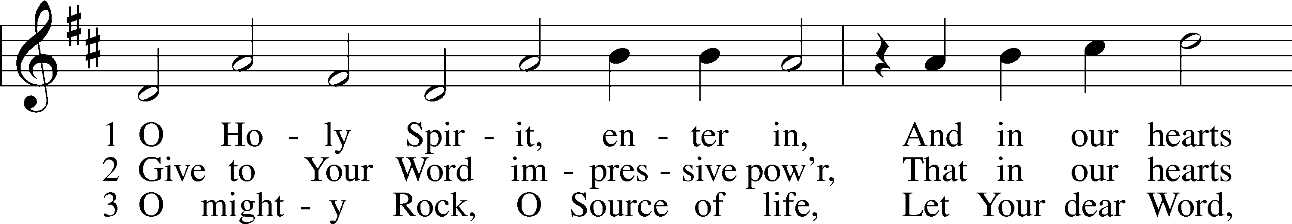
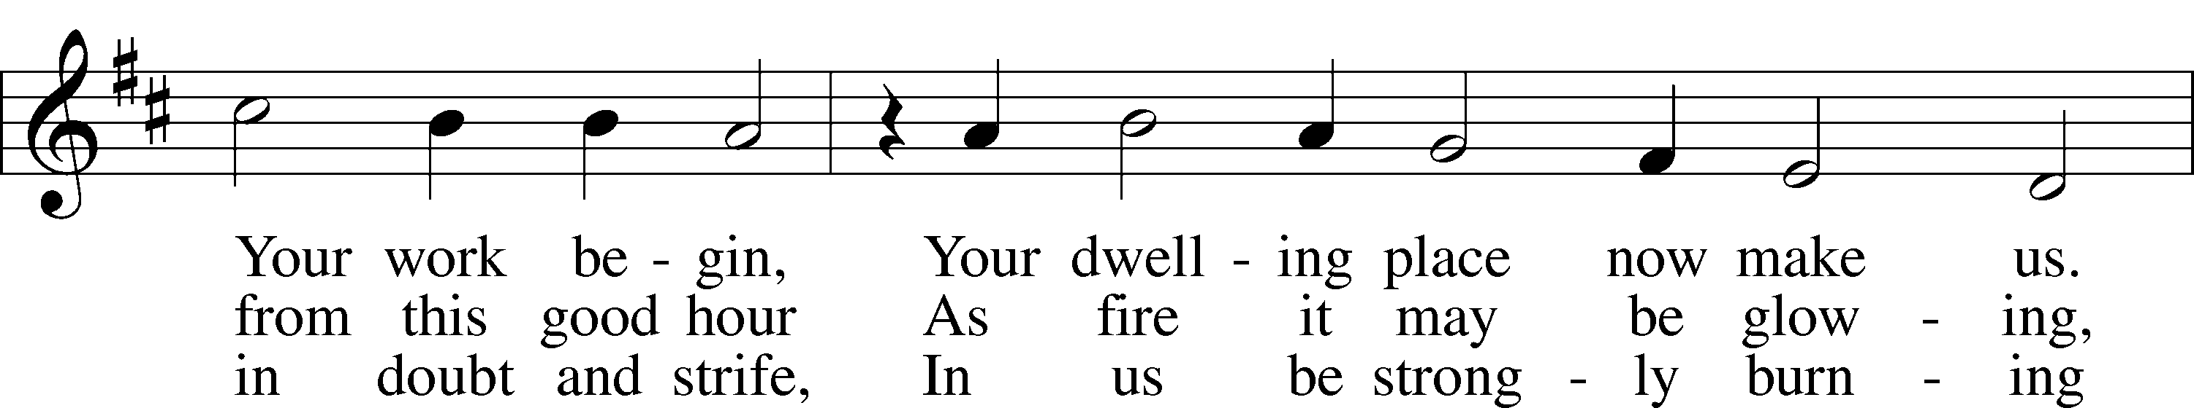
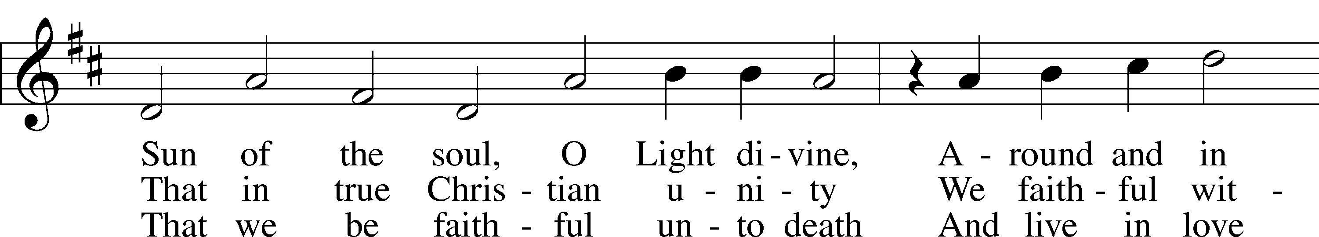
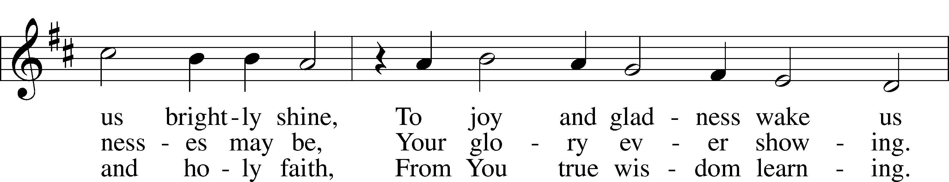
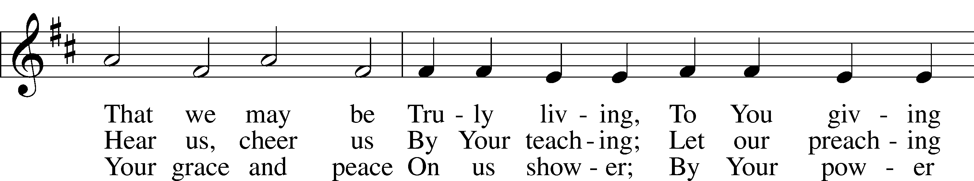
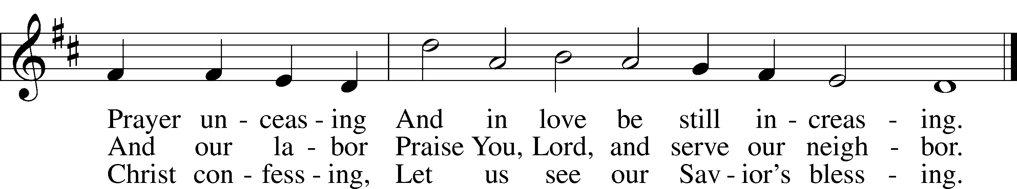
Text: Michael Schirmer, 1606–73, adapt.; (sts. 1, 3): tr. Catherine Winkworth, 1827–78, alt.; (st. 2): tr. The Lutheran Hymnal, 1941, alt.
Tune: Philipp Nicolai, 1556–1608 Text and tune: Public domain
Please stand as able
CONFESSION and ABSOLUTION
The sign of the cross may be made by all in remembrance of their Baptism.

P In the name of the Father and of the T Son and of the Holy Spirit.
C Amen.
P Our help is in the name of the Lord,
C who made heaven and earth.
P If You, O Lord, kept a record of sins, O Lord, who could stand?
C But with You there is forgiveness; therefore, You are feared.
P Since we are gathered to hear God’s Word, call upon Him in prayer and praise, and receive the body and blood of our Lord Jesus Christ in the fellowship of this altar, let us first consider our unworthiness and confess before God and one another that we have sinned in thought, word, and deed, and that we cannot free ourselves from our sinful condition. Together as His people let us take refuge in the infinite mercy of God, our heavenly Father, seeking His grace for the sake of Christ, and saying: God, be merciful to me, a sinner.
C Almighty God, have mercy upon us, forgive us our sins, and lead us to everlasting life. Amen.
P Almighty God, merciful Father, in Holy Baptism You declared us to be Your children and gathered us into Your one, holy Church, in which You daily and richly forgive us our sins and grant us new life through Your Spirit. Be in our midst, enliven our faith, and graciously receive our prayer and praise; through Your Son, Jesus Christ, our Lord.
C Amen.
SERVICE OF THE WORD
KYRIE LSB 204
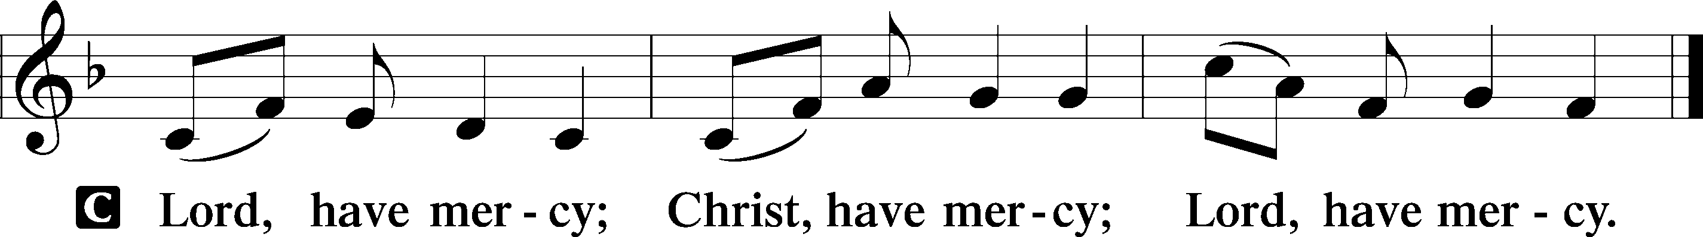
GLORIA IN EXCELSIS LSB 204
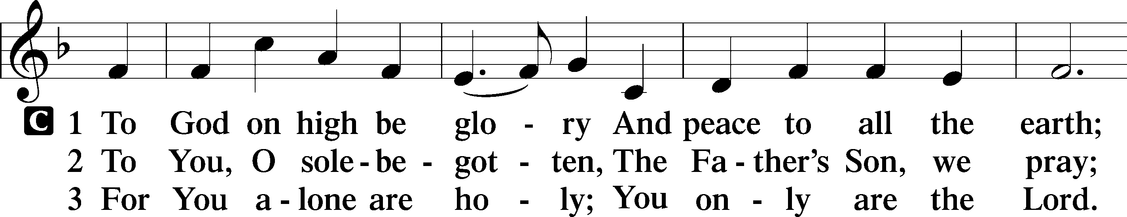
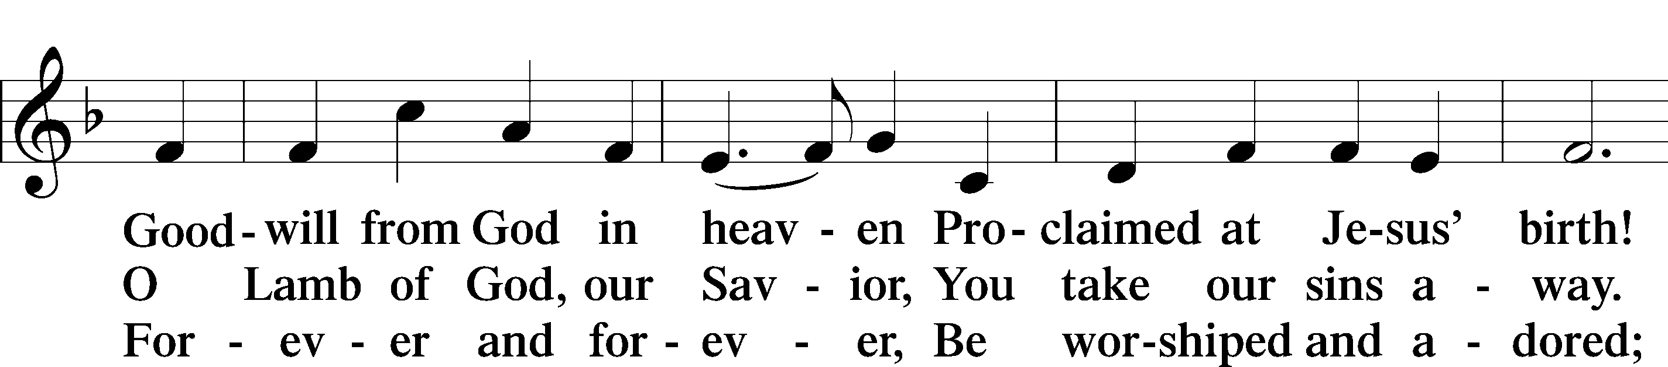
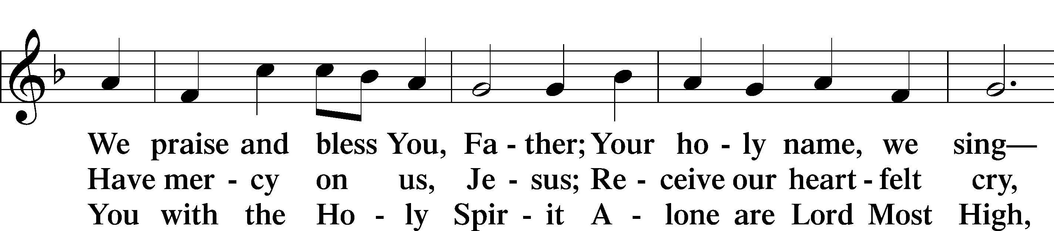
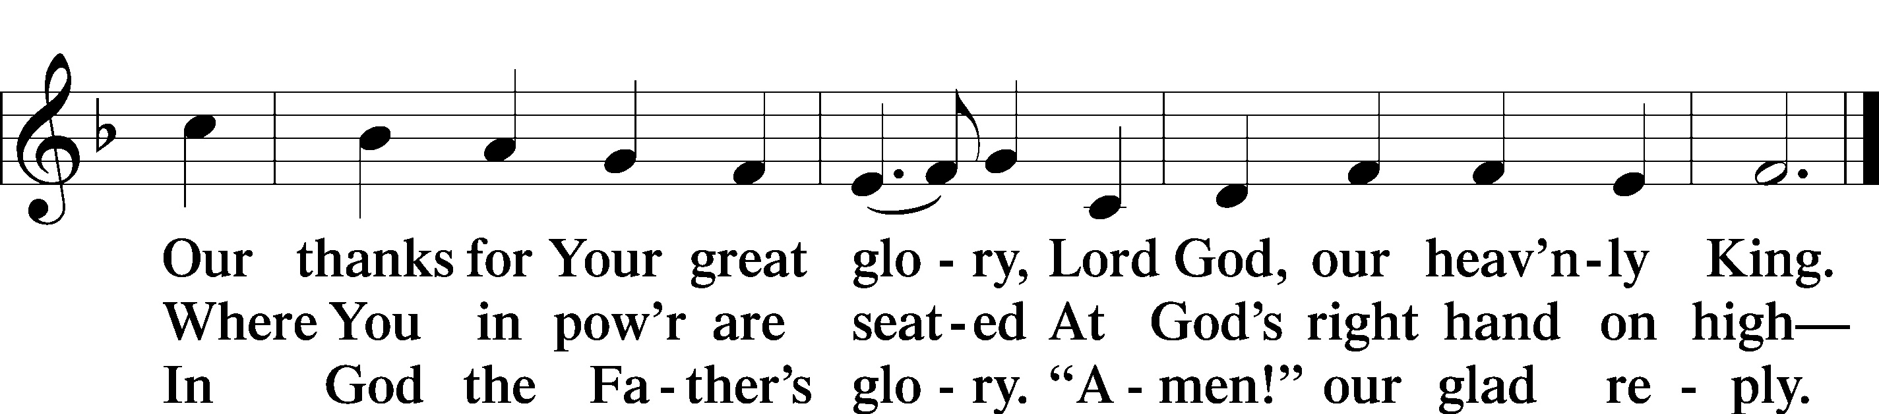
Text: Stephen P. Starke

SALUTATION AND COLLECT OF THE DAY
P The Lord be with you.
C And also with you.
P Let us pray.
O God, on this day You once taught the hearts of Your faithful people by sending them the light of Your Holy Spirit. Grant us in our day by the same Spirit to have a right understanding in all things and evermore to rejoice in His holy consolation; through Jesus Christ, Your Son, our Lord, who lives and reigns with You and the Holy Spirit, one God, now and forever.
C Amen.

Please be seated

OLD TESTAMENT READING Genesis 11:1–9
¹Now the whole earth had one language and the same words. ²And as people migrated from the east, they found a plain in the land of Shinar and settled there. ³And they said to one another, “Come, let us make bricks, and burn them thoroughly.” And they had brick for stone, and bitumen for mortar. ⁴Then they said, “Come, let us build ourselves a city and a tower with its top in the heavens, and let us make a name for ourselves, lest we be dispersed over the face of the whole earth.” ⁵And the Lord came down to see the city and the tower, which the children of man had built. ⁶And the Lord said, “Behold, they are one people, and they have all one language, and this is only the beginning of what they will do. And nothing that they propose to do will now be impossible for them. ⁷Come, let us go down and there confuse their language, so that they may not understand one another’s speech.” ⁸So the Lord dispersed them from there over the face of all the earth, and they left off building the city. ⁹Therefore its name was called Babel, because there the Lord confused the language of all the earth. And from there the Lord dispersed them over the face of all the earth.

P This is the Word of the Lord.
C Thanks be to God.

THE EPISTLE Acts 2:1–21
¹When the day of Pentecost arrived, they were all together in one place. ²And suddenly there came from heaven a sound like a mighty rushing wind, and it filled the entire house where they were sitting. ³And divided tongues as of fire appeared to them and rested on each one of them. ⁴And they were all filled with the Holy Spirit and began to speak in other tongues as the Spirit gave them utterance.
⁵Now there were dwelling in Jerusalem Jews, devout men from every nation under heaven. ⁶And at this sound the multitude came together, and they were bewildered, because each one was hearing them speak in his own language. ⁷And they were amazed and astonished, saying, “Are not all these who are speaking Galileans? ⁸And how is it that we hear, each of us in his own native language? ⁹Parthians and Medes and Elamites and residents of Mesopotamia, Judea and Cappadocia, Pontus and Asia, ¹⁰Phrygia and Pamphylia, Egypt and the parts of Libya belonging to Cyrene, and visitors from Rome, ¹¹both Jews and proselytes, Cretans and Arabians—we hear them telling in our own tongues the mighty works of God.” ¹²And all were amazed and perplexed, saying to one another, “What does this mean?” ¹³But others mocking said, “They are filled with new wine.”
¹⁴But Peter, standing with the eleven, lifted up his voice and addressed them, “Men of Judea and all who dwell in Jerusalem, let this be known to you, and give ear to my words. ¹⁵For these men are not drunk, as you suppose, since it is only the third hour of the day. ¹⁶But this is what was uttered through the prophet Joel:
¹⁷“‘And in the last days it shall be, God declares,
that I will pour out my Spirit on all flesh,
and your sons and your daughters shall prophesy,
and your young men shall see visions,
and your old men shall dream dreams;
¹⁸even on my male servants and female servants
in those days I will pour out my Spirit, and they shall prophesy.
¹⁹And I will show wonders in the heavens above
and signs on the earth below,
blood, and fire, and vapor of smoke;
²⁰the sun shall be turned to darkness
and the moon to blood,
before the day of the Lord comes, the great and magnificent day.
²¹And it shall come to pass that everyone who calls upon the name of the Lord shall be saved.’”
P This is the Word of the Lord.
C Thanks be to God.

Please stand as able

ALLELUIA AND VERSE LSB 205
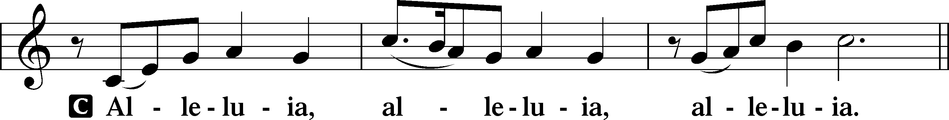
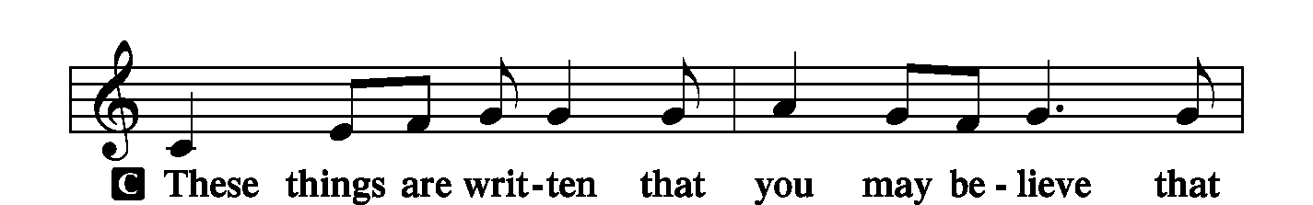
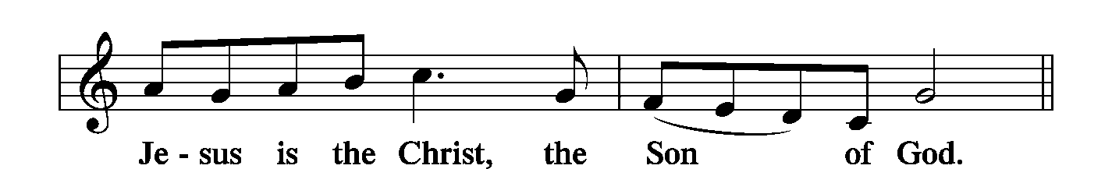
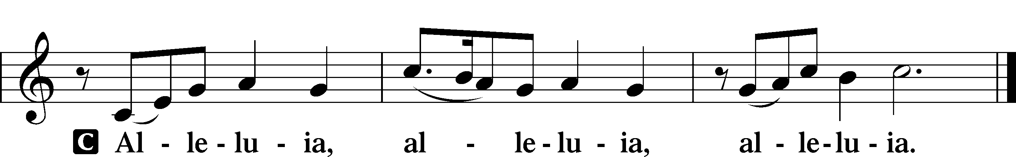

HOLY GOSPEL John 14:23–31
P The Holy Gospel according to St. John, the fourteenth chapter.
C Glory to You, O Lord.
²³Jesus answered him, “If anyone loves me, he will keep my word, and my Father will love him, and we will come to him and make our home with him. ²⁴Whoever does not love me does not keep my words. And the word that you hear is not mine but the Father’s who sent me.
²⁵“These things I have spoken to you while I am still with you. ²⁶But the Helper, the Holy Spirit, whom the Father will send in my name, he will teach you all things and bring to your remembrance all that I have said to you. ²⁷Peace I leave with you; my peace I give to you. Not as the world gives do I give to you. Let not your hearts be troubled, neither let them be afraid. ²⁸You heard me say to you, ‘I am going away, and I will come to you.’ If you loved me, you would have rejoiced, because I am going to the Father, for the Father is greater than I. ²⁹And now I have told you before it takes place, so that when it does take place you may believe. ³⁰I will no longer talk much with you, for the ruler of this world is coming. He has no claim on me, ³¹but I do as the Father has commanded me, so that the world may know that I love the Father. Rise, let us go from here.”
P This is the Gospel of the Lord.
C Praise to You, O Christ.

NICENE CREED
C I believe in one God,
the Father Almighty,
maker of heaven and earth
and of all things visible and invisible.
And in one Lord Jesus Christ,
the only-begotten Son of God,
begotten of His Father before all worlds,
God of God, Light of Light,
very God of very God,
begotten, not made,
being of one substance with the Father,
by whom all things were made;
who for us men and for our salvation came down from heaven
and was incarnate by the Holy Spirit of the virgin Mary
and was made man;
and was crucified also for us under Pontius Pilate.
He suffered and was buried.
And the third day He rose again according to the Scriptures
and ascended into heaven
and sits at the right hand of the Father.
And He will come again with glory to judge both the living and the dead,
whose kingdom will have no end.
And I believe in the Holy Spirit,
the Lord and giver of life,
who proceeds from the Father and the Son,
who with the Father and the Son together is worshiped and glorified,
who spoke by the prophets.
And I believe in one holy Christian and apostolic Church,
I acknowledge one Baptism for the remission of sins,
and I look for the resurrection of the dead
and the life T of the world to come. Amen.

Please be seated

“ALL GOD’S CHILDREN” TALK
PRE SERMON HYMN
Glorious Things of You Are Spoken LSB 648 sts. 1–2
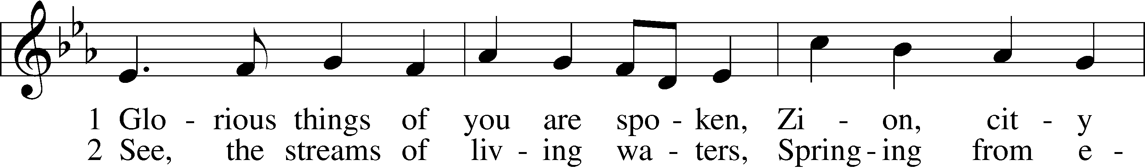
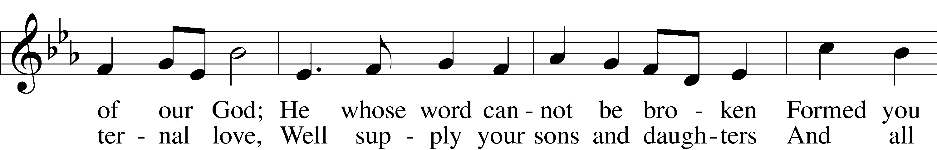
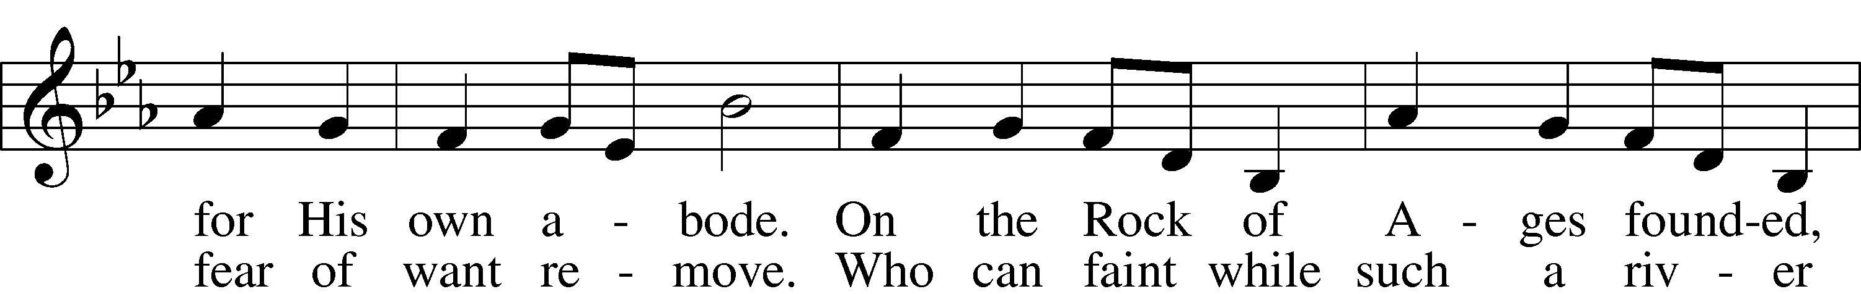
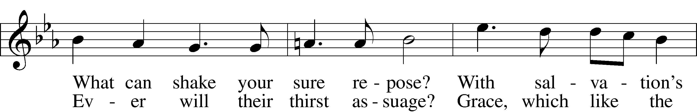
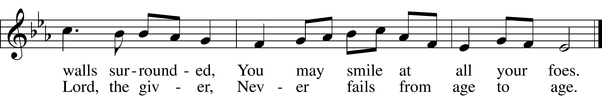

Text: John Newton, 1725–1807, alt.
Tune: Franz Joseph Haydn, 1732–1809
Text and tune: Public domain

SERMON

POST SERMON HYMN
Glorious Things of You Are Spoken LSB 648 sts. 3–4
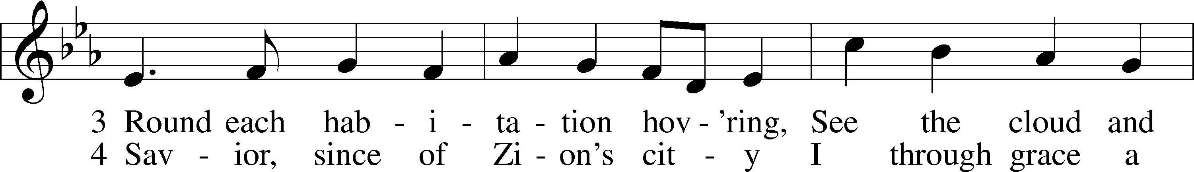
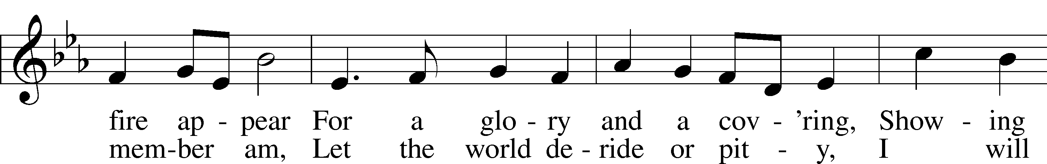
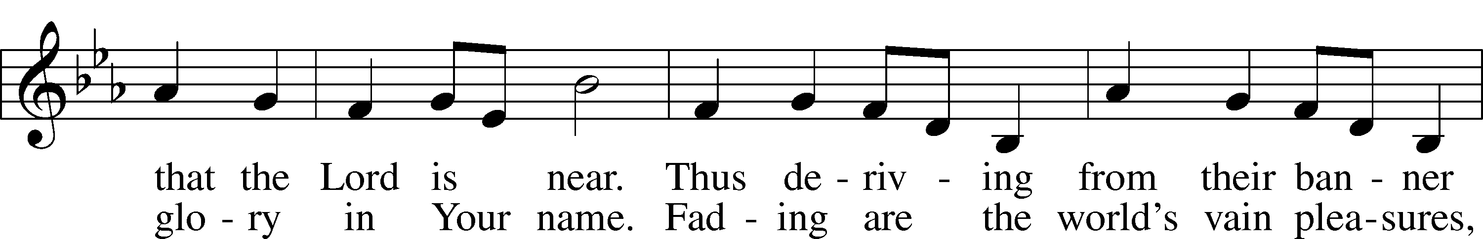
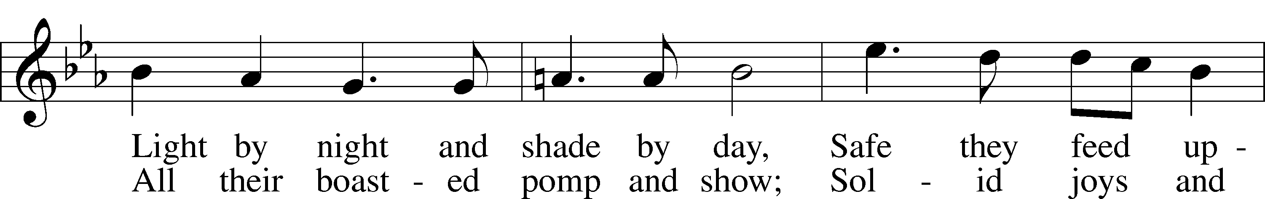
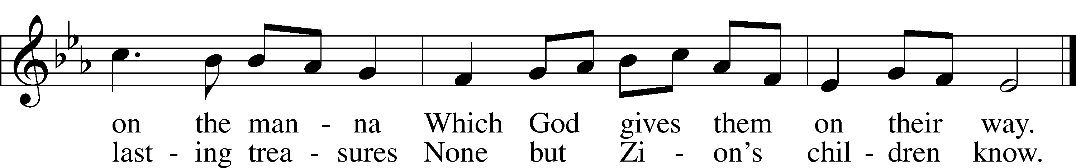
Text: John Newton, 1725–1807, alt.
Tune: Franz Joseph Haydn, 1732–1809
Text and tune: Public domain

PRAYER of the CHURCH
After each Segment:
P Lord, in Your Mercy,
C Hear our Prayer.
After Final Segment:
P Hear us as we pray in His name and as He has taught us:
LORD’S PRAYER
C Our Father who art in heaven,
hallowed be Thy name,
Thy kingdom come,
Thy will be done on earth
as it is in heaven;
give us this day our daily bread;
and forgive us our trespasses
as we forgive those
who trespass against us;
and lead us not into temptation,
but deliver us from evil.
For Thine is the kingdom
and the power and the glory
forever and ever. Amen.

Please stand as able

SERVICE of the SACRAMENT
PREFACE LSB 208
P The Lord be with you.
C And also with you.
P Lift up your hearts.
C We lift them to the Lord.

P Let us give thanks to the Lord our God.
C It is right to give Him thanks and praise.

P It is truly good, right, and salutary that we should at all times and in all places give thanks to you, holy Lord, almighty Father, everlasting God, through Jesus Christ our Lord, Who ascended above the heavens and, sitting at your right hand, poured out on this day as He had promised the Holy Spirit on the chosen disciples. At this the whole earth rejoices with exceeding joy. Therefore with angels and archangels and with all the company of heaven we laud and magnify Your glorious name, evermore praising You and singing:

SANCTUS LSB 208
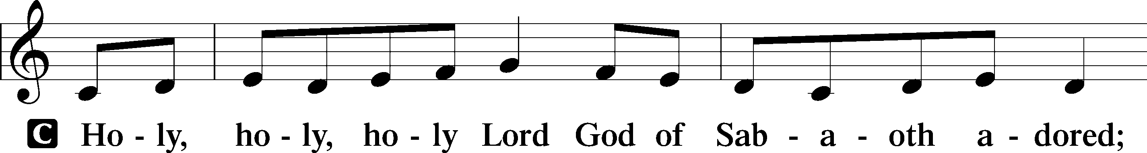
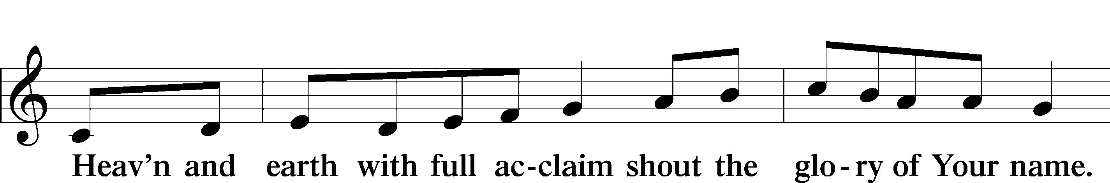
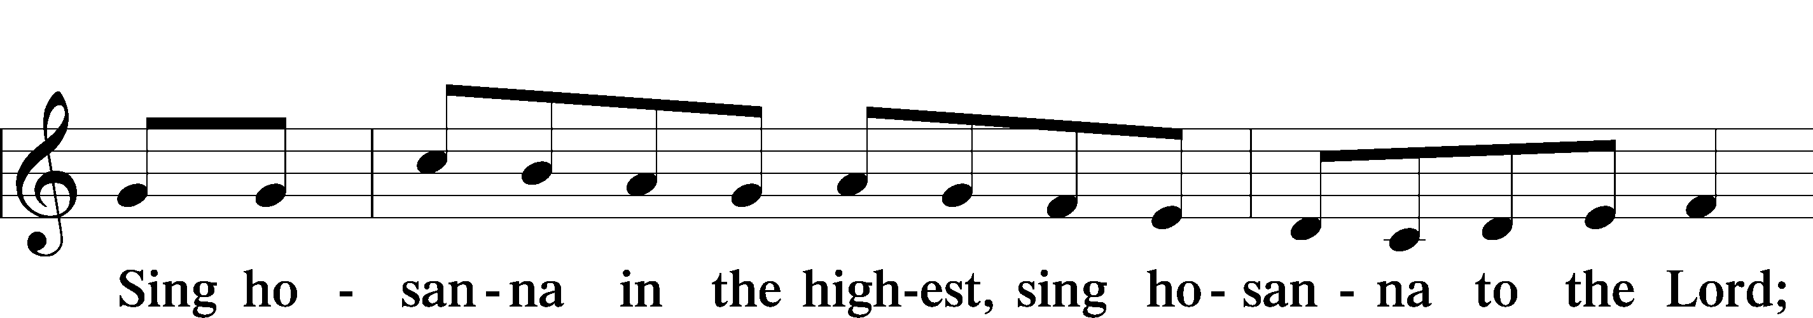

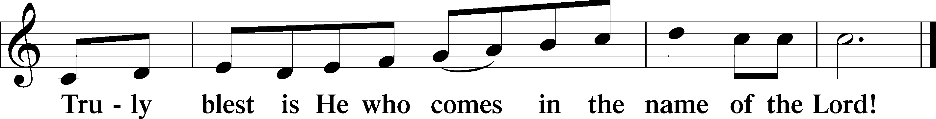

THE WORDS OF OUR LORD
P Our Lord Jesus Christ, on the night when He was betrayed, took bread, and when He had given thanks, He broke it and gave it to the disciples and said: “Take, eat; this is My T body, which is given for you. This do in remembrance of Me.”
In the same way also, He took the cup after supper, and when He had given thanks, He gave it to them, saying: “Drink of it, all of you; this cup is the New Testament in My T blood, which is shed for you for the forgiveness of sins. This do, as often as you drink it, in remembrance of Me.”

PAX DOMINI
P The peace of the Lord be with you always.
C Amen.
AGNUS DEI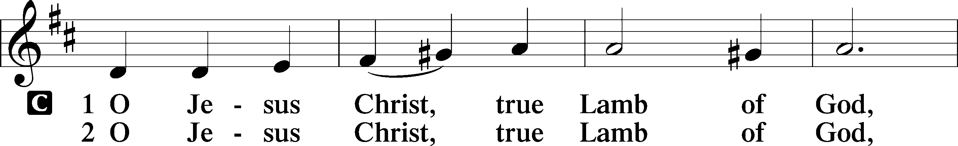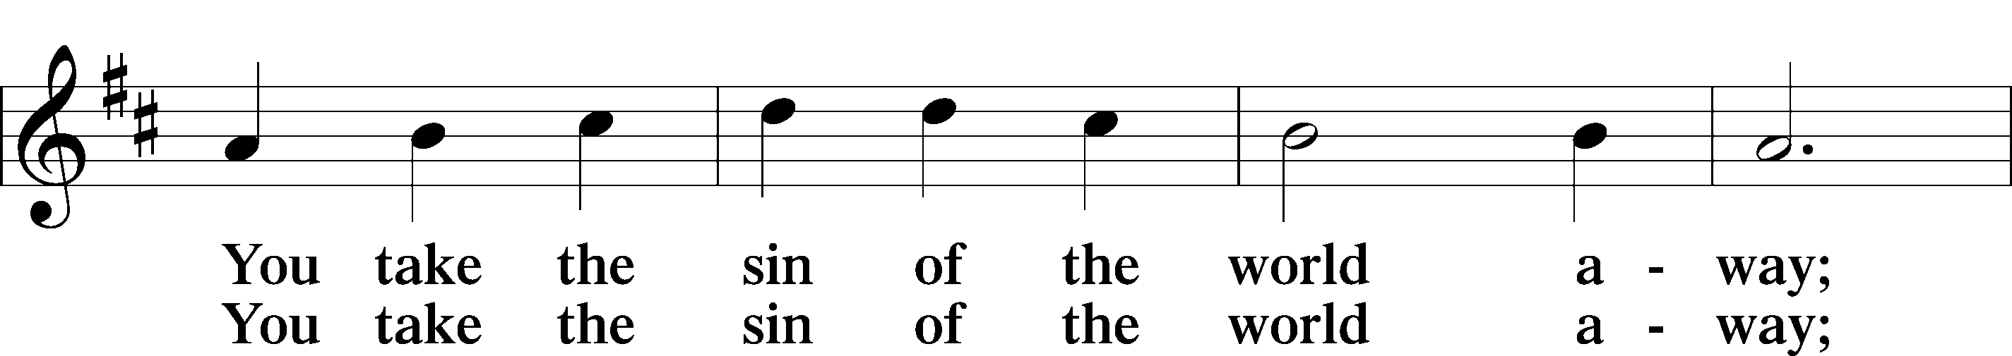
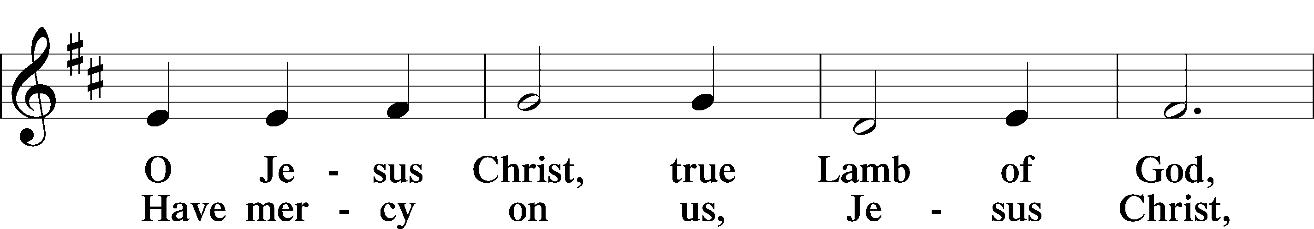
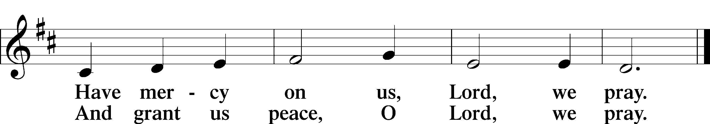

Please be seated

DISTRIBUTION
The pastor and those who assist him receive the body and blood of Christ first, then Communion will be served at the rail.. Ushers will help direct you forward via the center aisle; please return to your seats via the side aisles. Gluten-free bread is available for those who need it, as is non-alcoholic grape juice. Simply request either when you come forward to receive Communion.

DISTRIBUTION HYMN
Lord Jesus Christ, Life-Giving Bread LSB 625
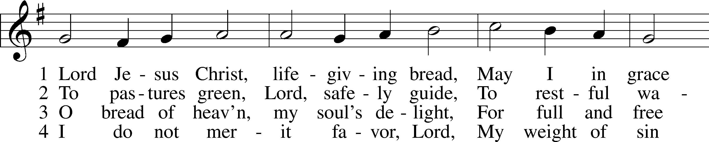
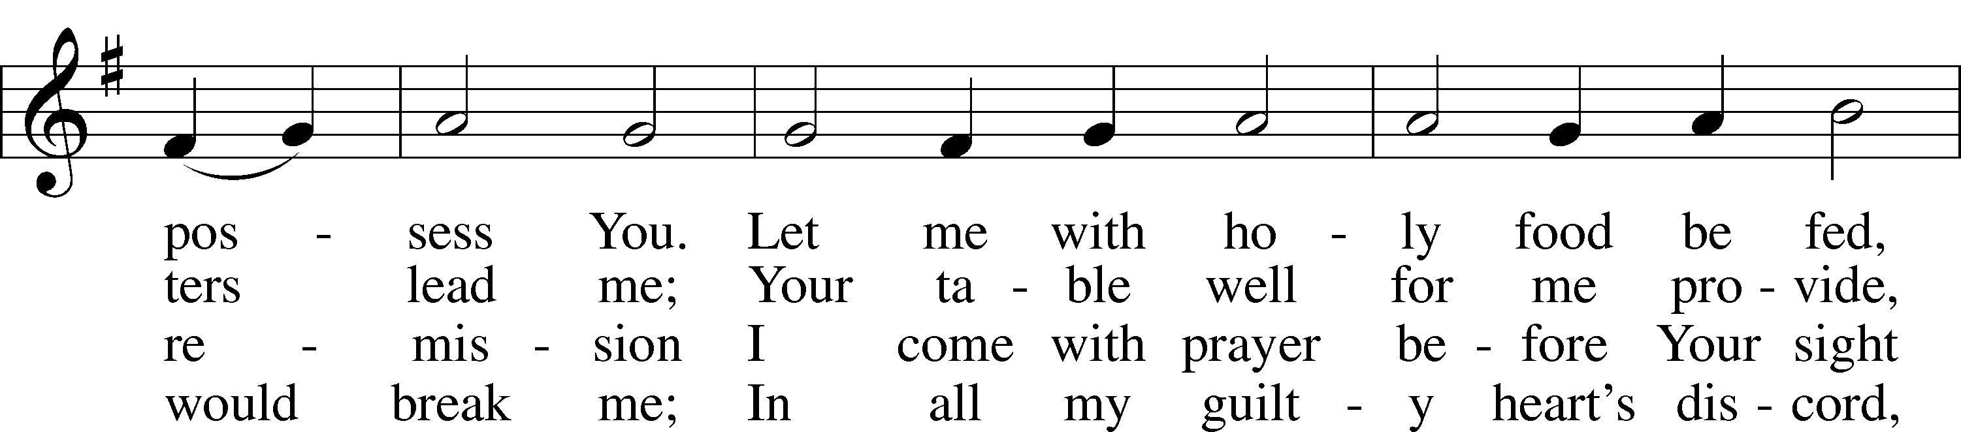
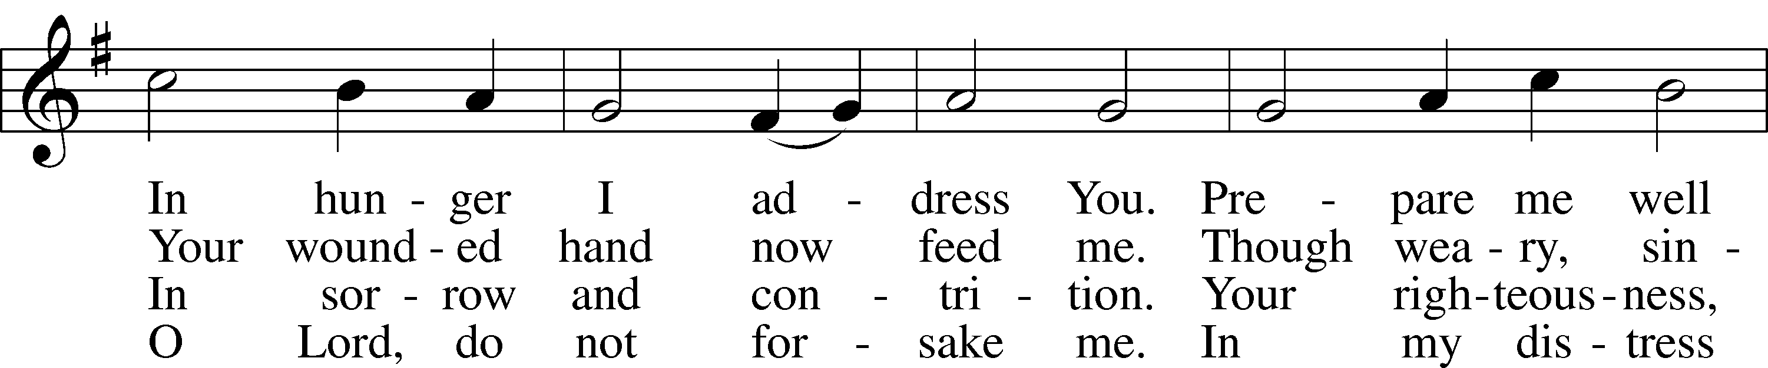
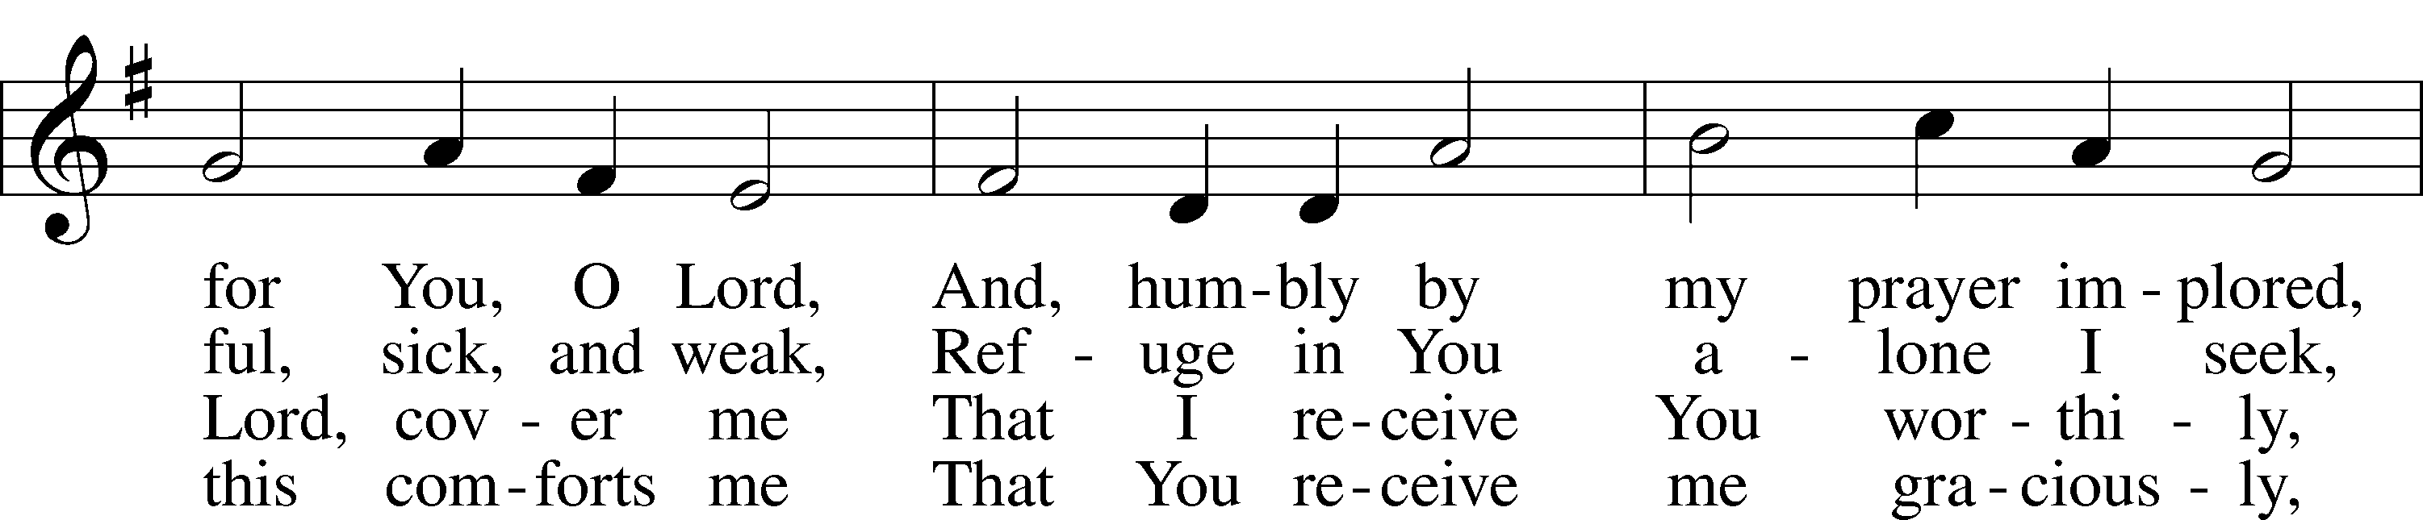
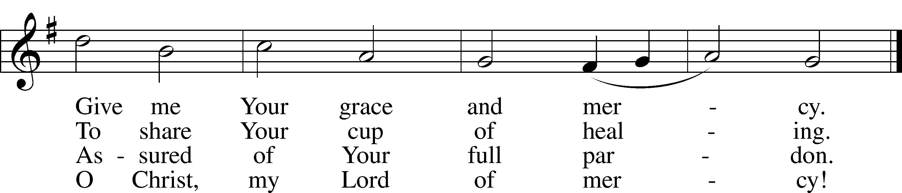

Text: Johann Rist, 1607–67; tr. Arthur T. Russell, 1806–74, alt.
Tune: Theütsch kirchen ampt, 1525, Strassburg
Text and tune: Public domain

Please stand as able
NUNC DIMITTIS LSB 211
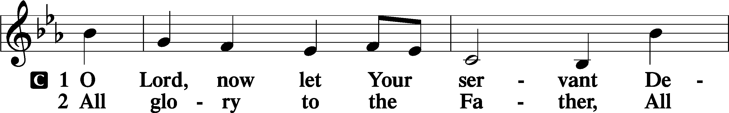
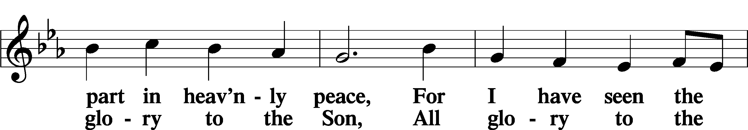
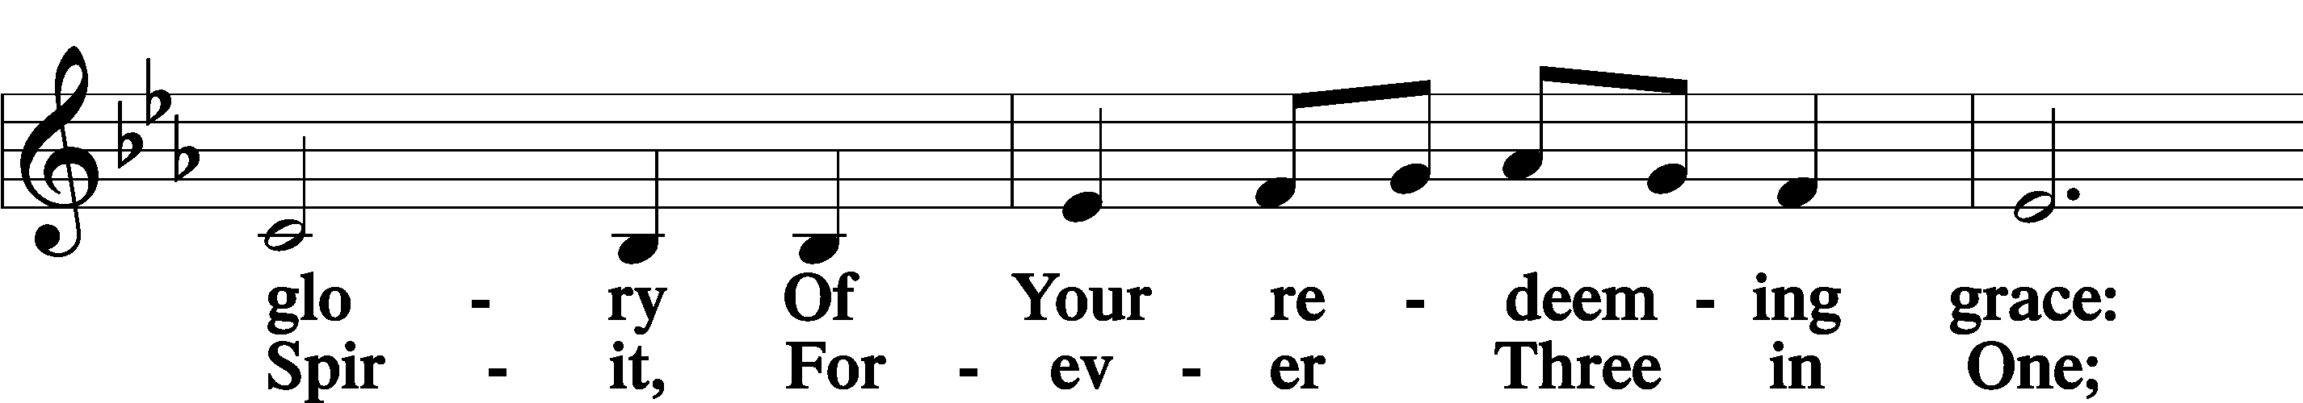
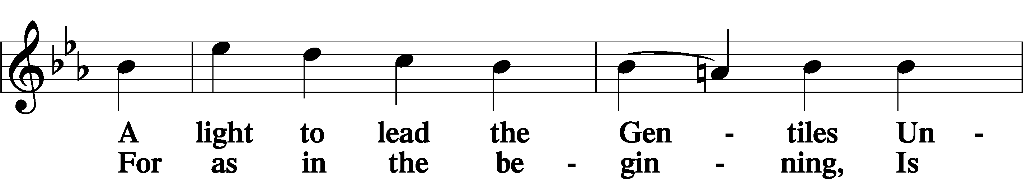
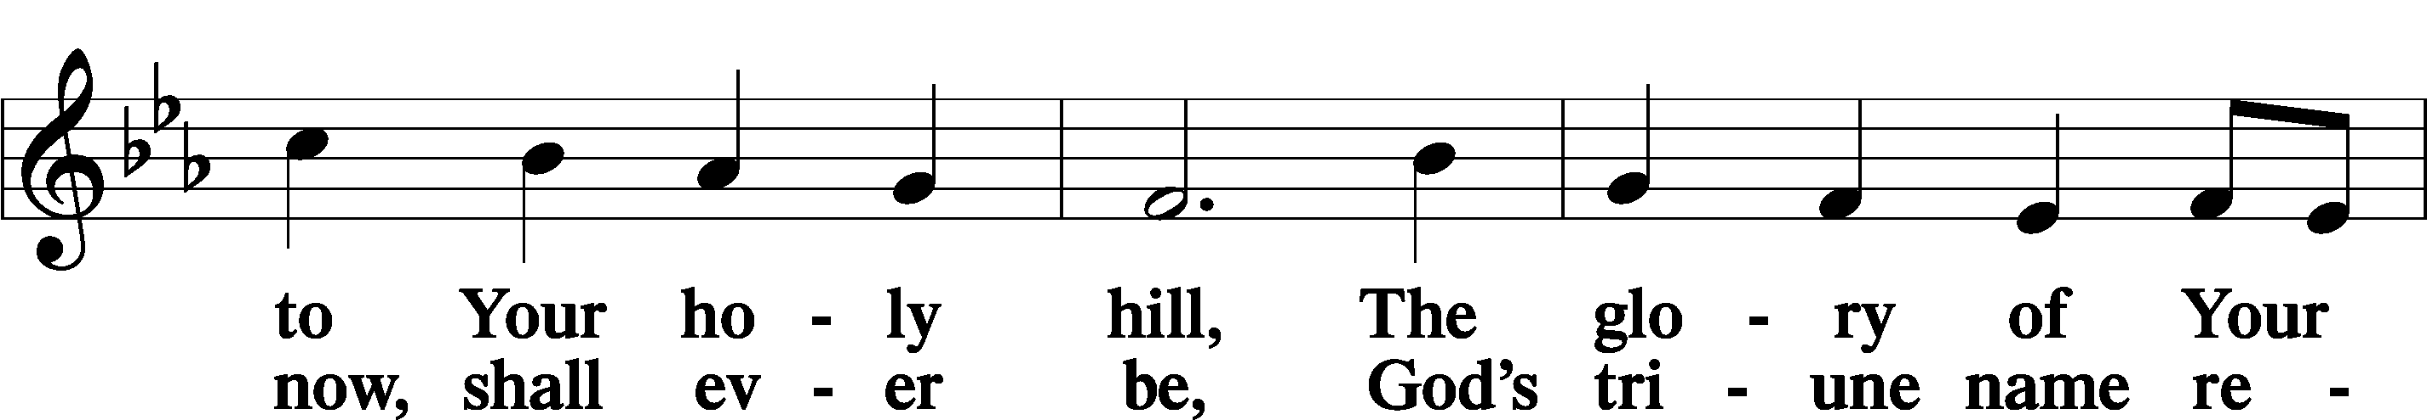
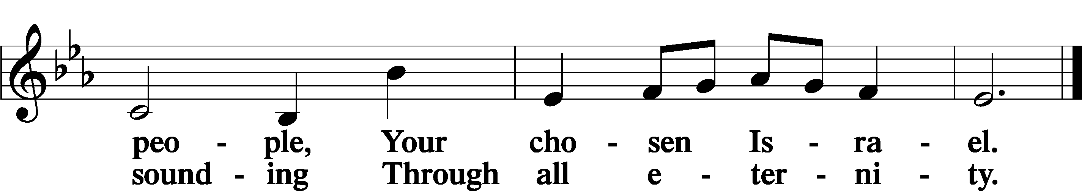

POST COMMUNION COLLECT
P Let us pray.
O God the Father, the fountain and source of all goodness, who in loving-kindness sent Your only-begotten Son into the flesh, we thank You that for His sake You have given us pardon and peace in this Sacrament, and we ask You not to forsake Your children but always to rule our hearts and minds by Your Holy Spirit that we may be enabled constantly to serve You; through Jesus Christ, Your Son, our Lord, who lives and reigns with You and the Holy Spirit, one God, now and forever.
C Amen.
BENEDICAMUS LSB 212
P Let us bless the Lord.
C Thanks be to God.
BENEDICTION
P The Lord bless you and keep you.
The Lord make His face shine on you and be gracious to you.
The Lord look upon you with favor and T give you peace.
C Amen.

Please be seated

CLOSING HYMN
Come, Holy Ghost, Creator Blest LSB 498 sts. 1–3, 7 Stand on st. 7
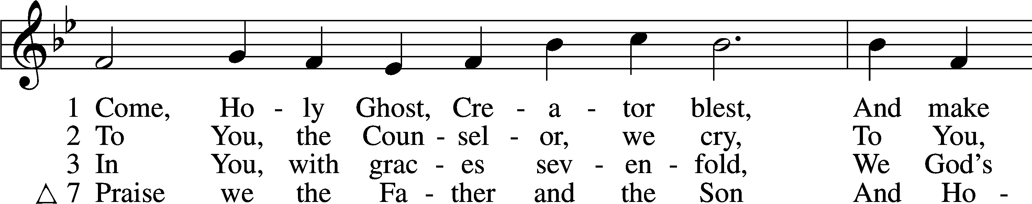
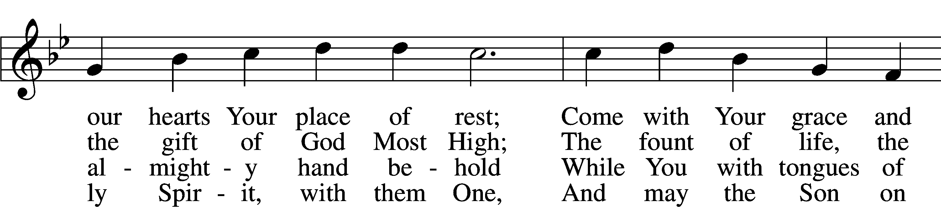
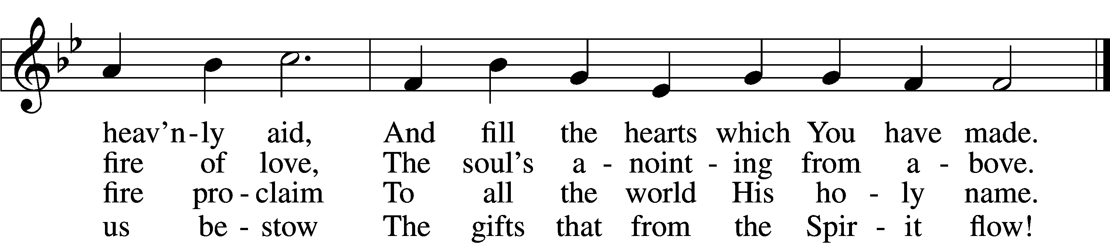

Text: attr. Rabanus Maurus, 776–856; tr. Edward Caswall, 1814–78, alt.
Tune: Geistliche Lieder auffs new gebessert, 1533, Wittenberg, ed. Joseph Klug
Text and tune: Public domain

ANNOUNCEMENTS and SENDING WORDS
P We go to live for Jesus!
C We go to share His love!

Acknowledgments
Unless otherwise indicated, Scripture quotations are from the ESV® Bible (The Holy Bible, English Standard Version®), copyright © 2001 by Crossway, a publishing ministry of Good News Publishers. Used by permission. All rights reserved. Created by Lutheran Service Builder© Concordia Publishing House.

SERVING in GODS HOUSE TODAY
Pastor: Rev. Paul Schneider
Elder: Glenn Smith
Ushers: John & Judi Stutzman
Greeters: Nancy Ely & Tina VanTil
Coffee: Stutzmans
Counters: Brian Techel, Karl Scheiterlein
Altar Care: Jeanine Boldrey
Virtual Organist: Bob Erat
Children’s Talk: Nancy Ely

PRAYERS
Please contact the office with updates to the prayer list. People will remain on the prayer list for 4 weeks before being removed. If they need to remain on the list, please keep Elaine informed and of any updates. This will help us to have a more accurate list. Thanks for your cooperation.

Those who continue to grieve the passing of loved ones, the family of Ruth Luebs, and the family of Kristy Francis.
Those with upcoming surgery:
Those recovering from surgery: Tanner Beyers, Sasha (Rose Dittmans Grandson), Jennifer Martin, and Ron Kwapis.
Those with health concerns: Tiffany Amsdill, Laurie Breen, Hope Buchinger, Betsy Cook Kay Gregg, Hilda Koch, Eleanor Raether, Beth Smith, Judi Stutzman, and Joann Whitney.
Those diagnosed with cancer: Leah Eicher, Rachel Frisch, Joe Gibson, Janice Knoellinger, Leslie Martin, Brian Morgan, Hope Osantowski,, and John Stutzman.
Those under Hospice Home Care: Ken Williamson, Jim (Joann Whitneys brother in law).
BIRTHDAYS: ANNIVERSARIES;
6/5 Brian Rood 6/6 Doug & Vicki Eicher
6/7 Tami Techel 6/7 Bob & Kathy Erat
6/11 Sandra Smith 6/11 Dean Vicki Edwards
6/10 Don Wenglikowski
6/12 Mark Mohr
6/12 Brian Techel

MESSAGES
ALTAR FLOWERS this week were given to the Glory of God by Glenn & Beth Smith,
In celebration of the 55 anniversary June 3rd.
OUTREACH PICNIC COMMITTEE MEETING: We are starting up again with our annual church picnic (This is not a dual parish picnic). Picnic is July 24th. This is the first meeting on putting together our church picnic. If you are interested in being part of this committee please sign up on the sheet on the board in the narthex. We can use all the help we can get on planning this picnic it is the first one since covid.
MEMBER & GUEST CARDS: If you have not filled out a member/guest card, please take the time to fill one out and place it in the plate behind the back pews in our sanctuary.

WEDNESDAY MORNING BIBLE STUDY will be taking a break for the summer and will resume sometime in September.

LWML SUMMER POP-UP CRAFT SALES: LWML plans to have occasional mini craft sales this summer. With short notice we will set up a few canopies in the front yard and offer our crafts for sale, with the profits designated for missions, both locally and throughout the world. Dates have yet to be determined. So, crafters, please get thinking about what handmade items you can prepare in advance for us to sell. We welcome and appreciate your donations.
FLOWERS: There are still spots open for Altar flowers, if you have birthdays, anniversaries, new baby or in memory of someone, or just for something special like dressing up the Altar. The signup sheet is in the fellowship hall as you go in the door. Flowers are $30.00 for the two flowers. Order them, they will be put on the altar, after the service then take them home to enjoy.
PORTALS OF PRAYER: For July-September 2022 are on the shelf in the narthex. Please feel free to take a copy home with you.
JUNE NEWSLETTER are on the shelf in the narthex feel free to take a copy.

THIS WEEK AT TRINITY
June 5 Sunday
9:00 am Worship Service - Holy Communion – Rev. Paul Schneider
10:00 am Fellowship & Coffee Hour
June 6 Monday
June 7 Tuesday
5:00pm Ladies Night out (Apple-bees)
6:30pm Elders Board Meeting
June 8 Wednesday
June 9 Thursday
1:00pm Ladies Guild Meeting Library
June 10 Friday
June 11 Saturday
June 12 Sunday
9:00 am Worship Service - Holy Communion – Rev. Paul Schneider
10:00 am Fellowship & Coffee Hour

